Editing the NewsScroller

Overview.

- The NewsScroller uses a simple text file on the server.

- The text file may be changed at any time to update the information displayed by the NewsScroller

- The name of the text file is my_news_scroller.txt
(Note file name is all lower case!)

- You must edit this file with a simple windows editor called Notepad

- This text file already resides on your PC.
This is the MASTER file which you make all of your changes to

- Once you have changed the file to show new information, the file must be uploaded to the server, where the news program reads from it to display your latest news information

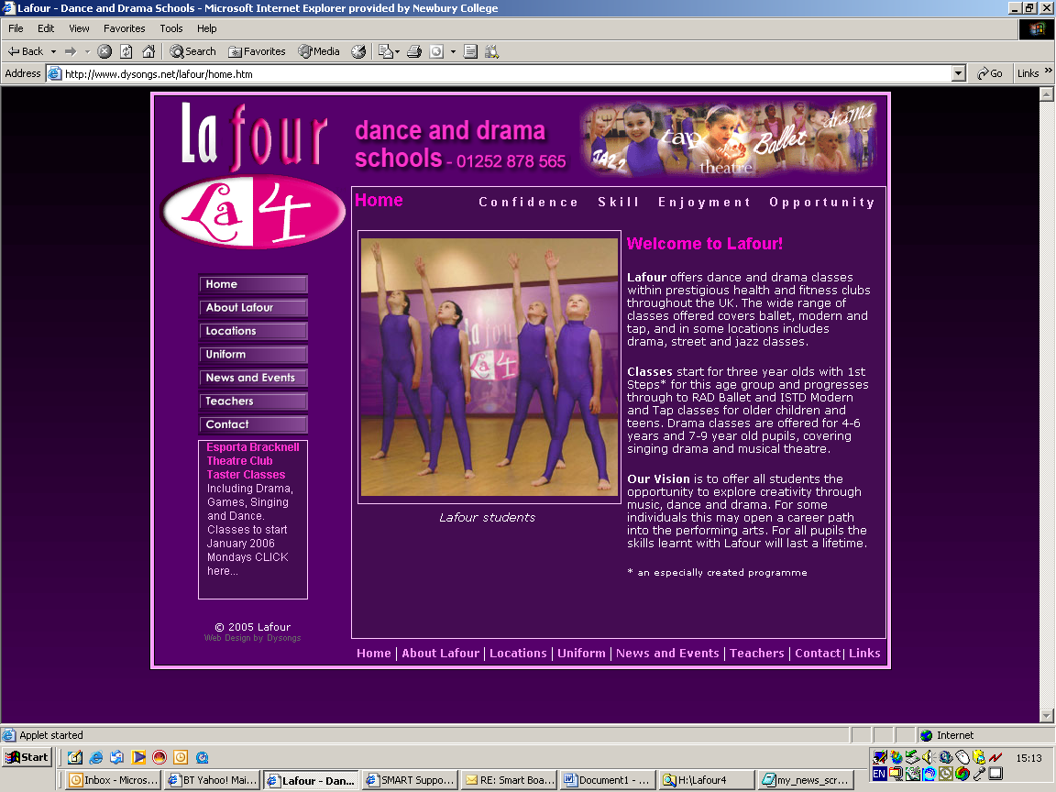

The NewsScroller

The Text File my_news_scroller.txt

- This file has a format which must be observed and obeyed to work.

- There are 4 elements to each news article

  - Element 1: The title of the news article

  - Element 2: The short blurb of the news article

  - Element 3: The hyperlink URL to the page the article
(optional) jumps to

  - Element 4: Browser Window (whether you use the
(optional) same browser window to display the page
you have hyperlinked or whether you use a
new window is definable

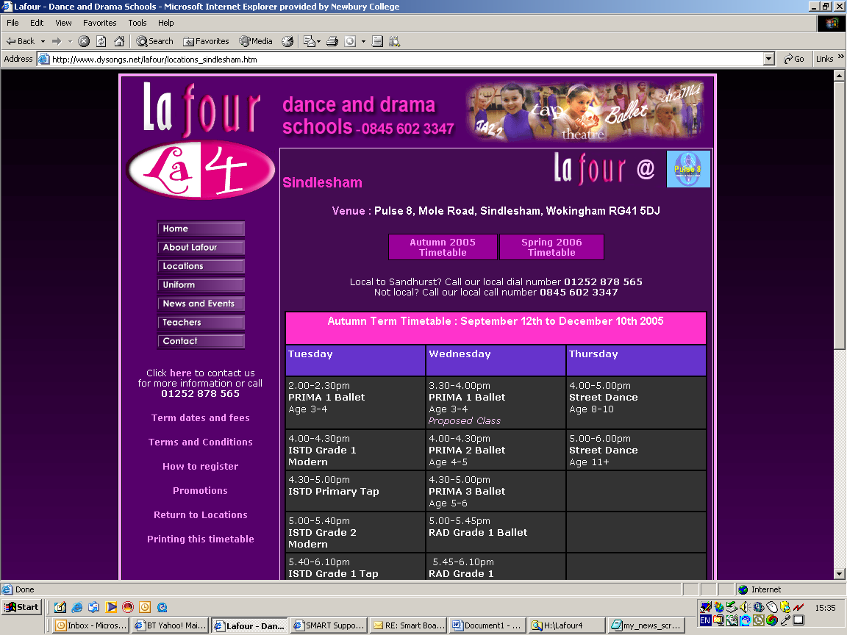

- Each of these 4 elements are represented by a line in the file my_news_scroller.txt

- Each element must be separated by a ‘bar’ character |
which is found to the right of the keyboards left Shift key

- Here is a typical layout of a single news article.

Special Offer | Free taster courses CLICK HERE… | tastercourses.htm | _blank

Explanation….

Special Offer will appear in bold type and coloured bright pink

Free taster courses CLICK HERE… will appear in normal type and pale pink

tastercourses.htm is the URL of an existing page on the Lafour website

_blank signifies that the page is to be opened in a new browser window

Here is sample of the text file of the news scroller as displayed in Windows Notepad.

Free Taster classes at Kingston|Lafour will be running free taster dance classes at Esporta on Wednesday September 14th More>>|promo_kingston.htm|_blank
Read our latest Newsletter|Catch up on all our latest news More>>|newsletter.htm|_blank
Nottingham free tasterclasses|Check out and enrol for free taster dance classes at David Lloyd on Monday August More>>|locations_westbridgeford.htm|_blank
A Lafour Dance Academy near to you!|We run dance classes throughout the south east and beyond! ||
Try a Street Dance class free at Wokingham|Friday 16th September - Free Street Dance session at Holmes Place More>>|promo_wokingham.htm|_blank

- Each line is a news article and these are separated by the bar (shown in red)

- There can be as many lines (news articles) as you like

- If there is no page to hyperlink to ( i.e. a news article is just a message with a title and a blurb) then omit the URL and the browser option as shown in the second to last line (see below)

A Lafour Dance Academy near to you!|We run dance classes throughout the south east and beyond! ||

- Note that the bars will be seen as black bars and not red. Also that some news articles’ text may spread over two or more lines in Notepad. This makes the lines just a little more difficult to read, so careful observation is called for before you change the data.

- Below is what you may actually see

Free Taster classes at Kingston|Lafour will be running free taster dance classes at Esporta on Wednesday September 14th More>>|promo_kingston.htm|_blank
Read our latest Newsletter|Catch up on all our latest news More>>|newsletter.htm|_blank
West Bridgeford - Nottingham free tasterclasses|Check out and enrol for free taster dance classes at David Lloyd on Monday August 22 More>>|locations_westbridgeford.htm|_blank
A Lafour Dance Academy near to you!|We run dance classes throughout the south east and beyond! More>>|locations.htm|_blank
Try a Street Dance class free at Wokingham|On Friday 16th September Lafour will be running a free Street Dance session at Holmes Place More>>|promo_wokingham.htm|_blank

Once you have edited and checked your file, you must save it. File > Save

Now upload the file to the server and your new information will be displayed by the news scroller.

